DAY-01

I have dataset of Market Campaign which I downloaded from Kaggle. We have to find the personality of the customer for our marketing campaign. So we have to analyze this data set. So first step is to make this data clean and redundance free. So below are the steps which we used to clean this data set and make it ready for data analysis.

1. The dataset which we download from Kaggle has all data in single column so we have to separate this data into different column. We use Text-To-Columns function in data tab.

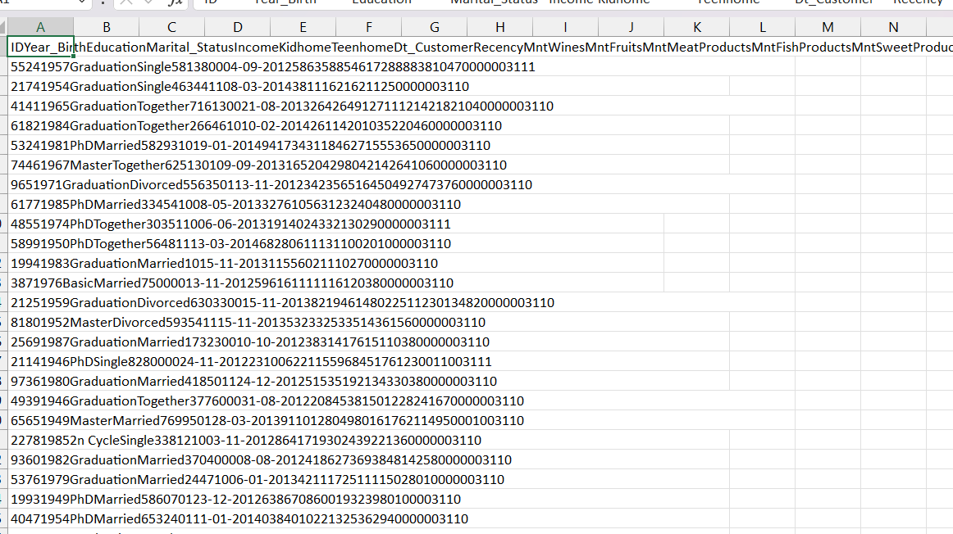

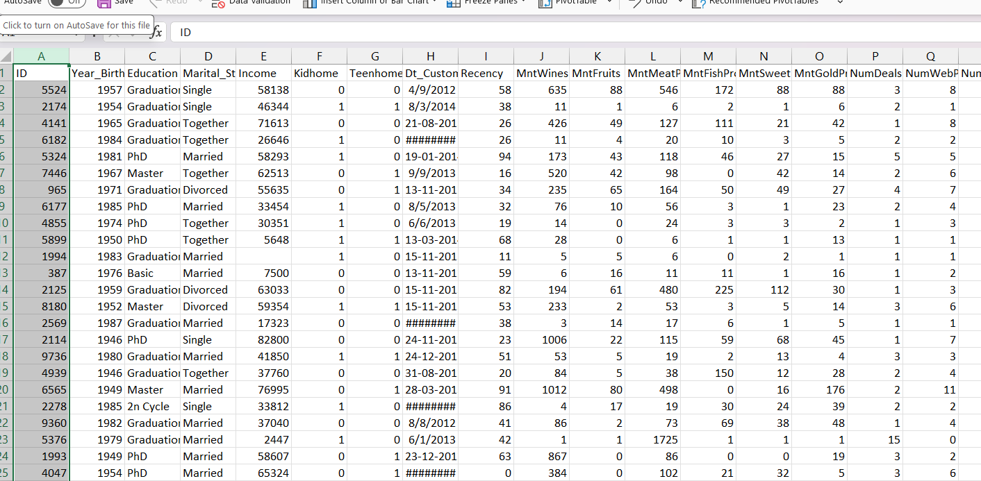I Convert the above data from this to the data below by using text to column function.

1. Then after separating the column, I analyze that there are many irrelevant columns in this dataset. Then I remove this irrelevant column from dataset.

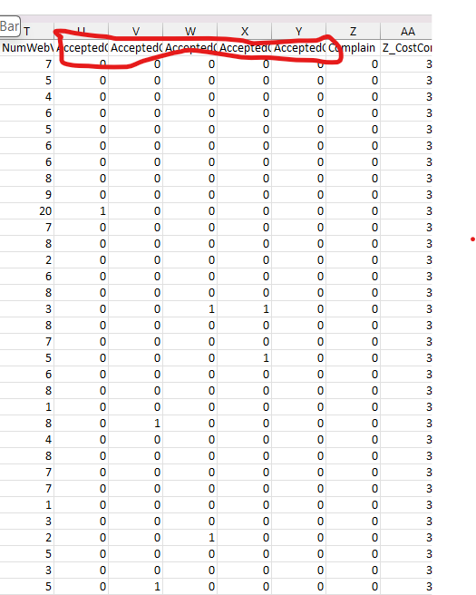

1. 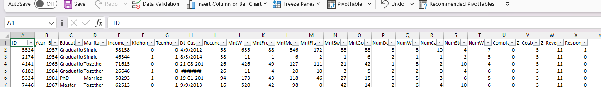After removing irrelevant column now next step is change column name and give clean and proper names to each column based on data they have.

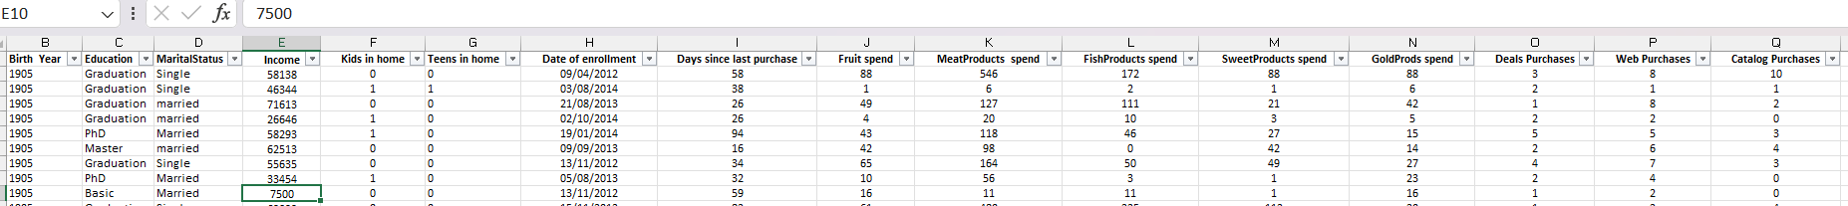from above to below

1. Now after changing column name next step is to change column data format according to the data, they have.

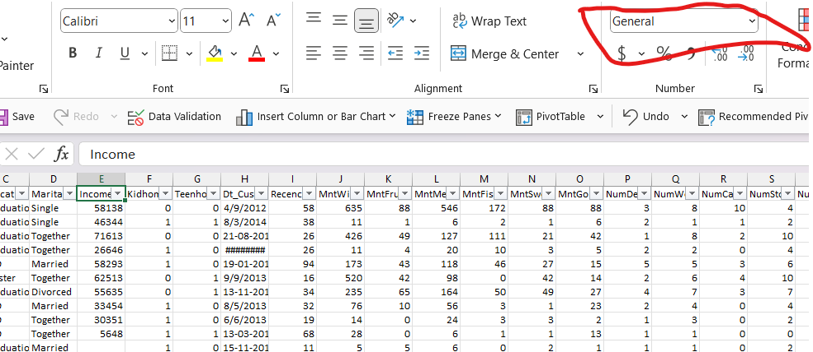

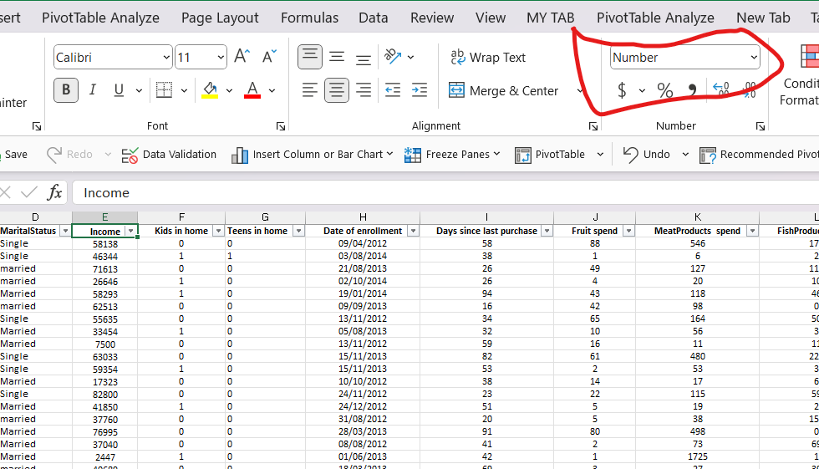

1. After changing column format next step is to apply filter and filter out null, blank and unwanted data from each column.

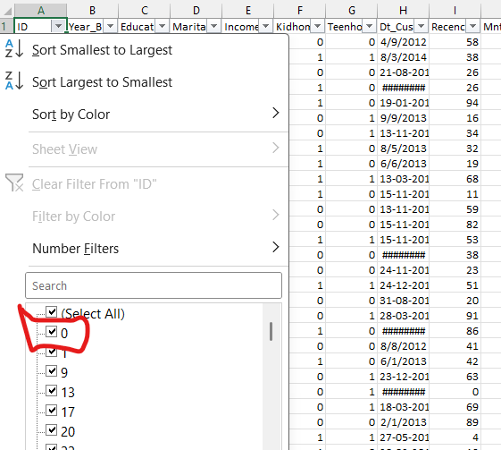

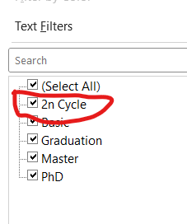

1. After this next step is to change values which has same meaning in a column to make it easy to analyze.

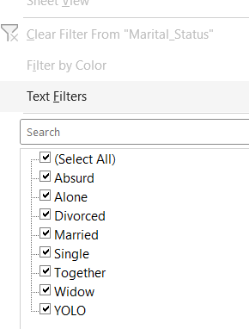

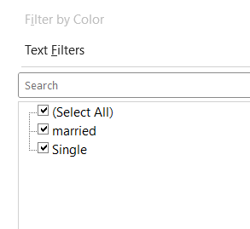

Now our dataset is clean and is ready for further analysis….